Iske pahle part 6 tk ka refine part 1&2 and refine part 3&4 files me he
Usko revise kr k hi aage bdna he.
Date: 22-july , 2026 , 07/22
Aaj k topics:
C is optimized
But neural network me python jeet jayega , kyuki vaha pr bahut bade bade matrix hoga.

Scaling: saaare data ko 0 se 1 k bich me le aao

Abhi humne puri file ka data ek baar me read kr k uske upar operations kr k model update kiya
But:
Issue: Agar huge dataset hua to kya hoga.
Process slow hogi. Matrix multiplication dikkat de jayeg.
Humne tarika kya apnaya.
All training example: process start kri , cost compute kri , weight update kiya to usko batch gradient descent bolte he

Stockastic gradient descent
1 training example picked at random , cost compute kri, weight update kiya , phir dursa training update kiya and so on , and har cycle pr weight update kiya
Ese 1000 examples k liye kiya ,
Ye sb andr k loop me chl raha he , vo outer jo he iteration wala vo to alag he
Outer wale k ek iteration me iske 1000 chle esa bol skte he

dono k bich ka : mini batch gradient descent
How: 1000 me se 100 liye ek batch
Ese kr k ek iteration me ye 10 baar chlega.
Humne jo function likha he uska naam change kr k batch_gradient_descent krna pdega

Mini batch and stockastics kese kre?
Ek data provider design karo: ek structure usme data file and provider function ko wrap kr do.
Ek function bnao jo structure ko create kr k initialize kre.
Ek function likho jo file se chunks me data read kre. Humnare case me kalu.();

Ye dataprovider ka address fit function ko do, fit function is se information le k iske andr wrapped kalu ka use kr k file se batch me data read kr k matrix me daal k then usko y vector and input matrix me split kr k operation perform kr k model ko update krega.
Testcases folder me:
Data provider ka implementation : data_provider.c me he
Stockastics ka implememtation : SGD_MBGD_with_DataProvider.c me he
And GNU plot pr model update dikhnae ka code SGD_MBGD_with_GNUPlot.c file me he.

In teeno ko compile krne ki lines compiletestcases.batch file me add ki he
Run kese krna he:
C:\ml-framework\utilities> line_data.out , is se line.data file bnegi
Is file ka use kr k testing and training csv bnana he
C:\ml-framework\utilities>create_training_testing_dataset.out line.data 0 training.csv testing.csv 70
In dono files ko testcases folder me dale and testcases folder me bath k ese model ko train kre
SGD_MBGD_with_GNUPlot.out training.csv 100000 0.00001
To check the accuracy use predict function: and use testing.csv and model.csv that is created after model train
Like below:
linear_regression_predict.out testing.csv model.csv

Next:
Stock , mini batch , scaling ki method bnana.
Next: polynomial regression pr kaam krna, Curve fitting krna for polynomial, Data set generate
2 featrue wala bhi chlega
Jyada feature hoge to boll jesa bn jayega
Kuch market related baate:
Java pe 7 saal ka exp , but ai ml se dur rahe means kbhi kaam nahi kiya
To company wale bolte he
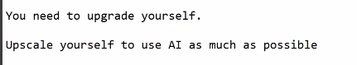
Jisne kuch dekha hi nahi ml ai but uske liye to weight term ho gaya.
End of the day unka mtlb he:
AI ko code base dena hota he.then vo uske andr ki function se related suggestion deta he,like copilot.
IDE me proper AI plugin install krna
Ab next:
To iske liye koi rasta khula he?
ML/AI ki team me ghus skte he kya?
Fresher level pr to certification ka koi mtlb nahi he.
Client ko chahiye ki programmer certified hona chahiye.
To uske liye kuch online programs he:
Online degree US, agar pesa and time he to ye explore krna chahiye[10 lakh tk ki hoti he]
Ye esi planning he ki iska result 2 saal baad dikhega.
ML engineer resume me aane k liye degree ek option he online wali.

Ml ai ki team me bhi vahi model tuning.
Quant pr crazy money he. Isme c++ pr hi kaam krnapdta he.

Standford , cmu se degree.
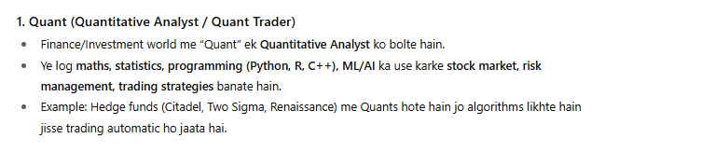
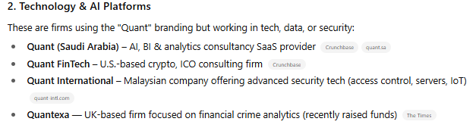
Part 7 tk ka summariaze ho gaya ab next part 8

part 8 : August 19, 2025
Feature normalizations [feature=input k har column ko ek feature kaha jayega]
Normalization mtlb , scaling and encoding krna data ko 0 se 1 k bich me lekr aana.
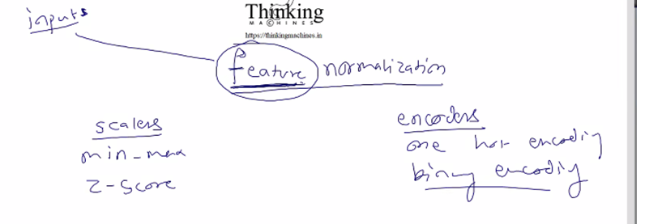
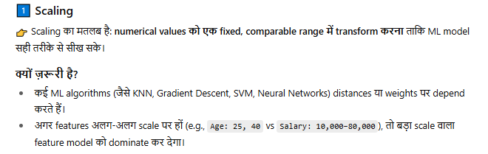
Dominate kr dega means result vo badi value ki taraf hi jayega, kyuki
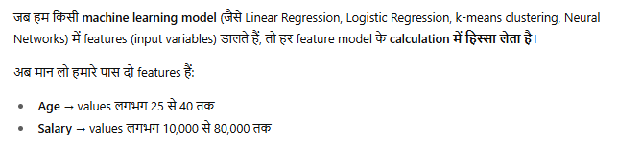
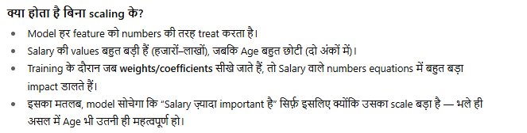
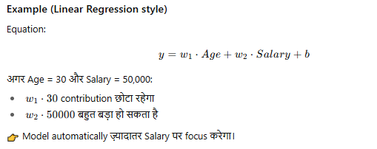
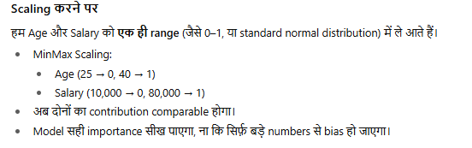

Scaling 2 tarike ki hoti he minmax and zscore:
Min-max scaling:
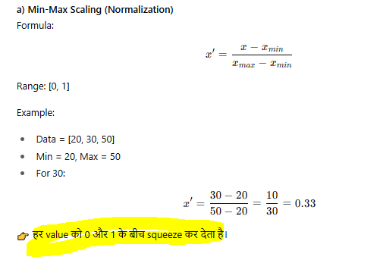

Z-score scaling:
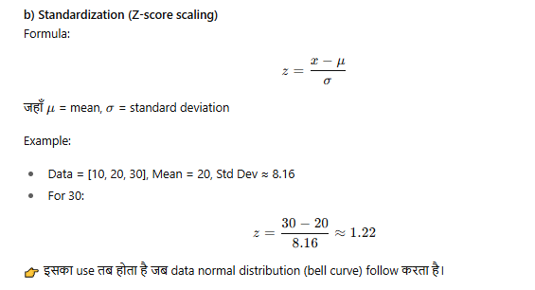
Ab standard deviation nikalna:
1 compute mean
2. substract mean from original value
3.isme negetiva aayega to usko kkhtm krne k liye square
4. again mean pta krna he isko variance kaha jayaega.
5. apply squere root output of step 4
Ye 5 step k baad jo aayega vo denominator me aayega
Ye sir ne baar bar likh k rat liya he.
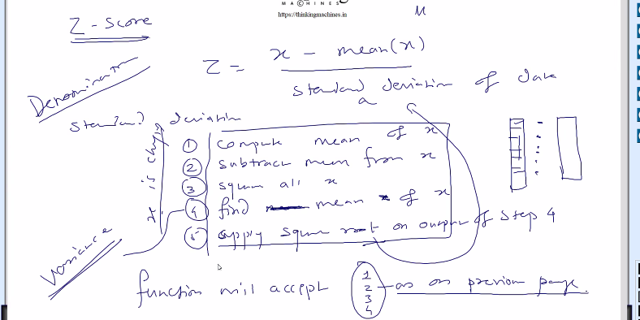

Ab jo ye functions bnege minmax() and z_score() ye kya lege as a parameter or what should function will accept?
Matrix? Nahi
Since Data jo he string form me bhi ho skta he[kis cell me data string form me he , like pointer to array of string]
To hum ese data ko humare bnaye hue matrix me store nahi kr skte.
Kyuki humara matrix to only double type ka data accept krta he.
To matrix me fill krne se phle humko esi process lagani pdegi jo string ko numeric me convert kr de.
But esa krna galat he. Humare pas to double wala implementation he matrix ka.
Ye preprocessing wala kaam he, ye linear regression wala kaam nahi he, uske phle ka kaam he
To for the time being hum file se read krege then data k upar normalization lagayege and ek nayi file me save krege.
Future: matrix ka esa implemetaion esa ho ki matrix ka har columm kuch alag data type aa ske.
Jese Java me object,python me infer kr leta, Abhi ye sb nahi krna , abhi sidha file pr kaam.
To function will look like : fn(input filename, outputfile name,Vetor, skiplines)
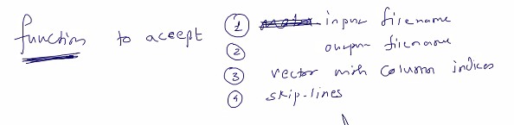
3rd parameter ek vector hoga jiske andr column k indices hoge.
Why ? Dataset me kuch columns he jiske against string pdi he to unhi columns ko hume encode/scale krna he, jiske against string pdi he.
Kisi bhi scaling k algo k liye ye kaam kr jayega, only function k andr ka formula bdlega.

Encoding: 1. One hot encoding 2. Binary Encoding
Maan to koi color data he ,
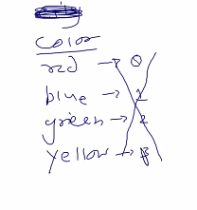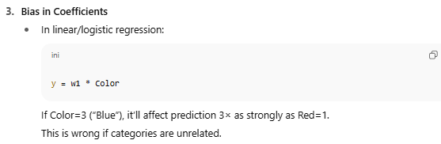
Encodeing k liye number de do but ye galat he , how?
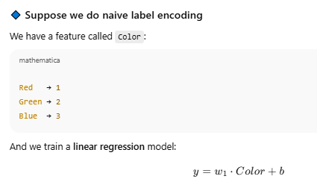
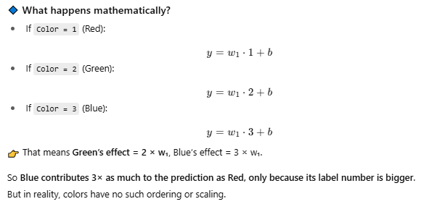
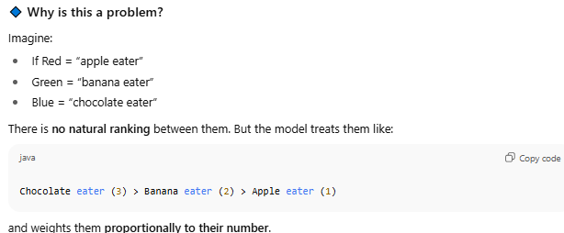
Verdict: Tranining me mathematics biased hoga high weight ki taraf
To isliye one hot encoding introduce hua:
One hot encoding:
To one column will be removed and n new column will be added [n means unique data/strings presents in that columns]
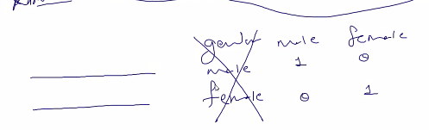
E.g. output file me gender naam ka column remove hokr gender_male and gender_female columns bn jayege.
And jis row me ramesh he usme male ko 1 and female ko 0, and Jis me rekha he usme male ko 0 and female ko 1
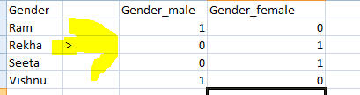 esa bnega final
Same for color jisme jis type ki value usko 1 baki ko 0
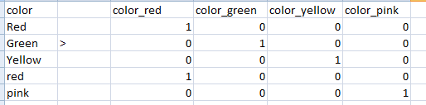

Isko one hot encodeing bolte he:
Isk e liye bhi same argument wala function
Koi feature he jiske pass 95 alag alag string he o 95 columns bd jayege.
Dimesion bdega to processing time khayega. To iske liye aaya Binary encoding
Binary Encoding:

Suppose color column me 8 color he to one hot encoding k hisab se 8 columns bnege.
But binary encoding me 3 column me kaam ho jayega.
Kese?
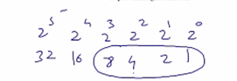
2 different numbers/objects ko represent krna 1 digit require
4 different numbers/objects ko represent krna 2 digits reuires [3,4 numbers k liye 2 digits hi aayega]
8 different numbers/objects ko represent krna 3 digits reuires [5,6,7,8 numbers k liye 3 digits hi aayega]
16 different numbers/objects ko represent krna 4 digits reuires [9-16 different objects k liye 4 digits hi aayega]
Abhi suppose input matrix k feature column me 8 unique color names he unko represent krne k liye 3 digits me kaam ho jayega
2 ki power 0 2ki power 1 and 2 ki power 2 , [2^0,2^1,2^2,2^3]
Color wala columns remove hokr 3 column bnege color-0, color-1 , color-2
0,1,2 are the names based on the power of 2.
Ab humko kuch nahi krna he. Humko har value ko ek integer id assign krna he and max wali value k hisab se columns decide krna he , e.g. 13 unique values[0-12] to unko represent krne k liye 3 bits lagegi
To hum 0 se lekr 12 tk assign kr dege un 13 colors ko and then har ka binary nikal k un bits ko in 3 columns me bicha dege.
ee.g.
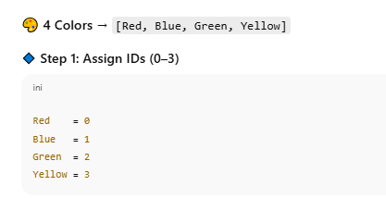
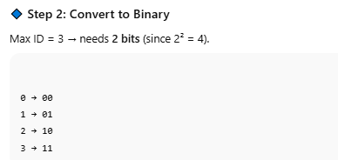
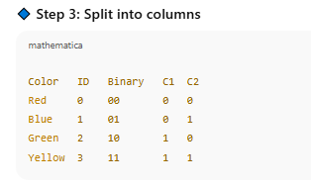
Final 2 cloumns bnege color-1 and color-2.
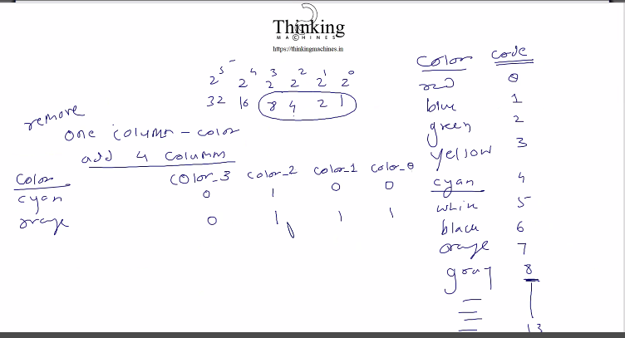

Ab inke implementation ki baat kre:
But column me jo color name ki string pdi he usme kis color ko kya code dena he?
Algo code de de ya user code specify kare?
User ko unique set of string de do and then he create the code for each and gives code to us. Bad practice.
To finally algo decide kr le and user ko gyan de de ki kiska kya code he.
Now suppose user ne ye vector diya: and specify kiya ki input file k in columns me encoding krni he.
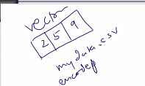
Jitne column ki baat kri utni file bnani pdegi , to 3 files bnegi and usme feature values and uska code.
Data analyst ye kaam krta hoga, usko yaa to gui tool ya excel pe kaam and formula ki training di jaati hogi and karo kaam scaling and normalization ka.

File ka name saamne wale se bulwana ya khud hi filename generate krna?
Abhi to hum hi naam generate krege.

Normalization ki coding:
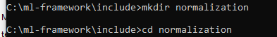

Prototype is added, Now see the sudo code:
Min max ka algo:
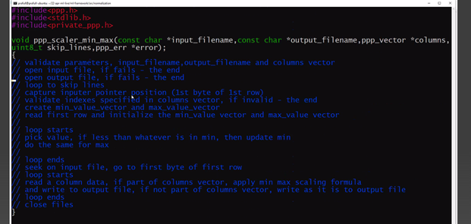
Zscore ka algo:
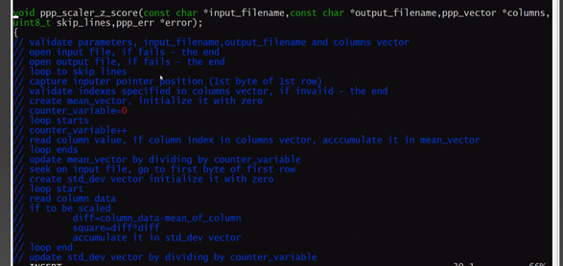
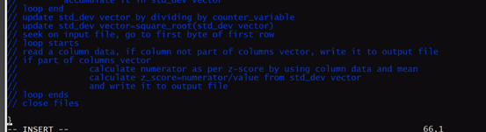
Pending: iski coding , ye to algo he bs
Next: encoding ka algo , inka bhi implementation pending he.
One-hot-encoding:
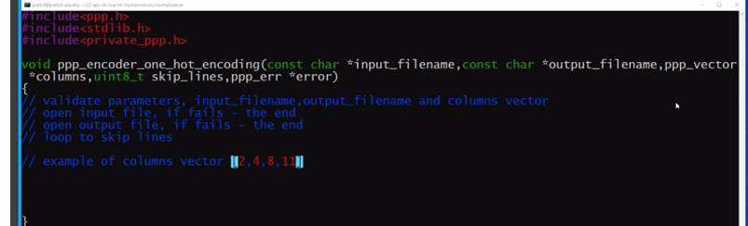
Suppose ek index pick kr k is vector me se and input matrix me us index wale column k saree cell pr traverse kr k saare strings ko ek set of string me daalte jayege,
set se decide ho jayega ki ab kitne column bnege us ek column k badle me.
Same thing for other indexes picked from vector.

Ab Ek ek kr ke pdege to galat ,
To create an array of sets , according to size of the columns vector e.g. in case of above image we will take array of size 4, where each element of array points to a set of string.
Set is of type string.

Naye columns k naam kya? Suppose humare paas 2 columns he age and pet and pet wale me strings he, then new columns will be like: Age pet1 pet2 pet2 pet…. OR Age petcat petrat petdog
To first wala approach use krege: Jo naye column ka naam rahega originalname_setkivalue.
But ab jo vo line skip krwa raha he vo header nahi he and combo of kuch ho like title.
Ese case me Standard csv parser bhi dhng se parse nahi kr payega.
So, Ek decision lena he ki usi hisab se csv bnani pdege, Nahi to phir vo csv parser bnane wali baat aa jayegi.
Algo of one hot encoding:
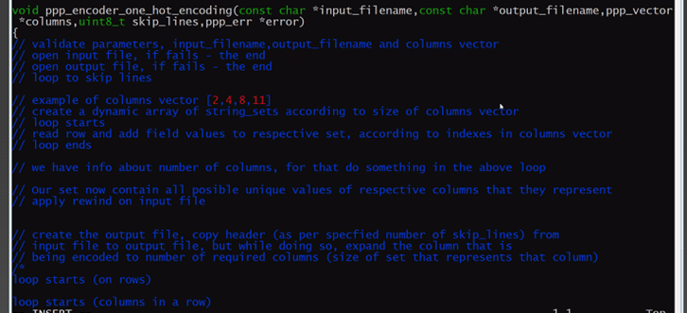
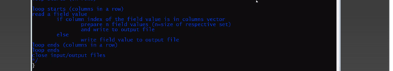

Binary encoding algo:
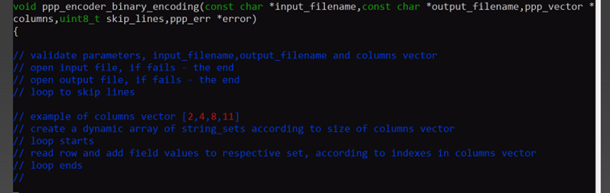
Kahani yaha k pahuchne k baad 4 sets ready ho jayege,
For example take a vector where we need to en code three columns, whose index in input matrix is 4,,9,17.
Har column se ek set bna , ese total 3 sets bne as below, each set contains all unique string in that col.
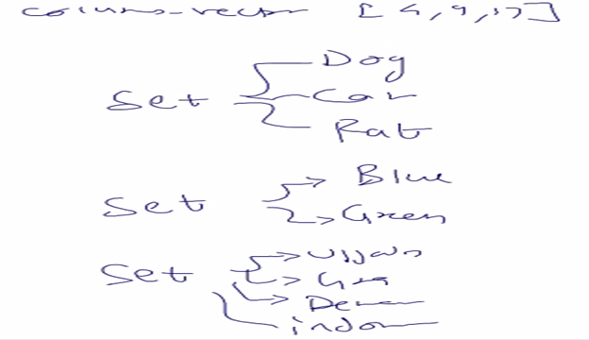
Ab in sets ka address ek array me rahega us array ko sets naam dege as below
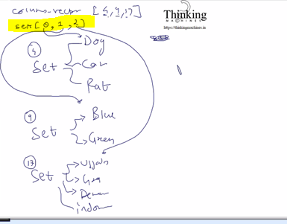
Sets k 0 index pr input matrix k 4th index wale column ko traverse krne se bna set
Set k 1 index pr input matrix k 9th index wale column ko traverse krne se bna set
Set k 2 index pr input matrix k 17th index wale column ko traverse krne se bna set

Ab outputfile bnate he:
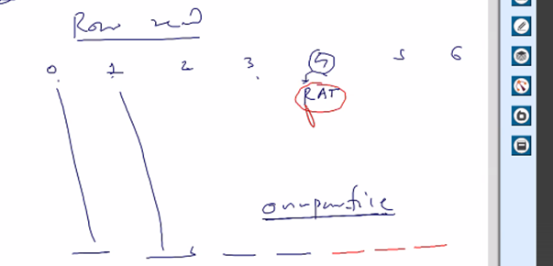
Vector [4,9,17] he to inke liye hi column replace hoge baki columns as it is coppy paste
e.g. 0,1,3 index wale columns to as it is copy kr diye from input file
not 4th index pr aaye , isme humne dekha ki ye vector me he and iski encoding krni he
ab konse column ko kitne columns me expand krna he ye kese pta chlega ?
iske liye vo binary wala concept: humare paas total 3 sets he, in set ki size he [3,2,4]
4th wale se jo bna uski size 3, 9th wale se jo bna uski size 2 , 17th wale se jo bna uski size 4.
ab size ko represent krne k liye vo bit wala rule
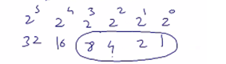
Kitne bit lgege ye power wali value se pta chlege
So size 3 k liye 2 bit, size 2 kliye 1 bit, size 4 k liye 2 bit
To size wale array ko further refine kiya based on the bits to bna
[4,9,17] (column index that needs to be expanded to encoding) (next is the array that represent size of each set created by traversing the column at index mention in vector [4,9,17])
[3,2,4] (number of elements in each set, this array represents the size )
[2,1,2] (no. of bits require to represent all elements of that set) this array represent the final number of new columns to be created for the respective column at index in [4,9,17]
Means 4th index wala 2 column me , 9th index wala 1 column me , and 17th index wala 2 column me divice hoga.
Summary:
First set me 3 element to 2 digit me aa jayega [00 10 01 11] =2
Second set me 2 element 1 digit me aa jayega like [0,1]=1
Third me 4 element vo bhi 2 digit me aa jayega al like [00 01 10 11]=2
Set ki size , then size-1 ka binary coz 0 base le rahe he.
Size-1 ka binary nikal k, usme jitney bits aa rahe he us length ki us pair me string rahegi.
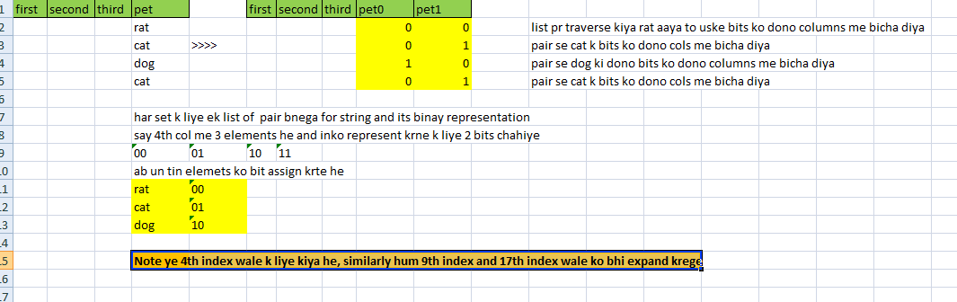

Next session Tuesday,: 4 sude code , 2 scalar, 2 encoders
Set and pair phle bna liye jayege,
Set me bhi tree ya hashing ka algo , string se hashcode generate ho
Dynamic data me tree hi maintain krna feasible he, red-black tree.
Sir to simple growing array bnayege.
Generic redblack tree ki lib bna rkhi he sir ne.
Naam uska set rahega, jb humari ichha ho tb vo piche ka algo bdla jaa skta he.

Yaha tak part 8 finish.
Pending : implementation of scalars and encoders.

Part 9: Date: September 4, 2025
Logistic Regression: this is for classification problem
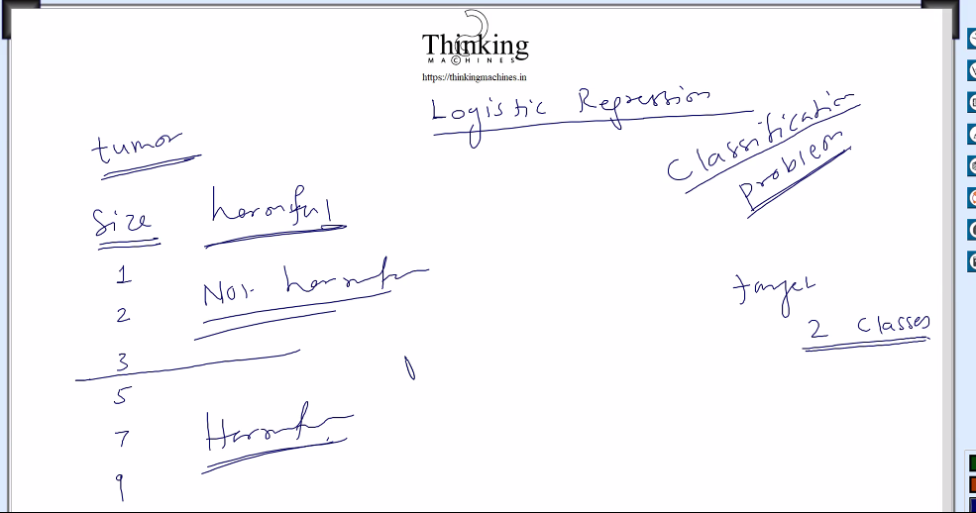
Let say 2 features he tumor size and inko 2 target classes me divide krna he based on the size
Say 1-3 are not harmful and 5-9 are harmful.
Say model train kr diya using logistic regression , then Trainging k baad humare model ko btana hoga ki tumor harmful he ki nahi based on the size
Ye 2 classes wala tarika use kr k 6 clasess ka kaam bhi ho jayega

Tumor ko 2 class me divide kiya.
Data ko 2 class me devide kiya harmful and non harmful
Ek class ko 0 se and dusri ko 1 se represent krege.

Jisko predict kr rahe he usko hypothesis bolte he.
Linear regression k case me hypothesis function MSE tha:
h theta (x): h means hypothesis, theta means parameters [in case of linear regression theta was model vector filled by random values], x means features [input matrix X]
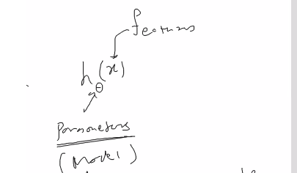
So linear regression k case me humara function tha : X * theta = X matrix * model vector = 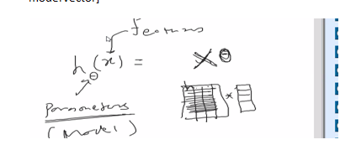
Y = mx +c => y = x*m +c
No. of columns in x = number of rows in theta m.
To isi ko bolege hypothesis function: derivatives ki theory apply kr k humne model ko update kiya tha in linear regression , model vector updataed during back propagassion using derivative theory.

Linear reg me line fit wali baat thi.
Ab tumor ki baat krte he:
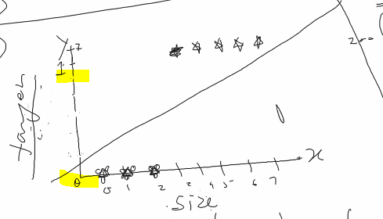
X axis pr size and Y axis pr target [harmful / non harmful means 0/1]
1,2,3 k liye non harmful means 0, 4,5,6,…. K liye armful mtlb 1.
To Y axis 0 and 1 me divide ho jayega.

Q: kya is case me hypothesis function X * theta ho skta he?
A: nahi kyuki X*Theta se jo value produce hogi vo 0 and 1 k bich ki hogi iski guarantee nahi he, So this hypothetical function X*Theta will not work for classification problem

Hypothesis me predicted value Above 0.5 ko 1, below 0.5 ko 0 manege and accordingly penalty compute hogi and model update hoga.
But in case of X*theta predicted value 0 and 1 k bich aane ki koi guarantee nahi he.
So isko 0 and 1 k bich lane k liye sigmoid ka use krege:
So logistic regression k case me[Gradient desent ] k case me function hoga, X*theta ko sigmoid me wrap krna, X * theeta k result pr sigmoid apply kr dege.

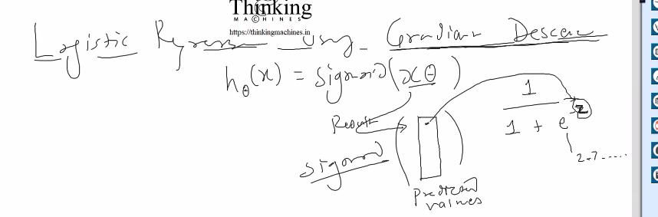

Means z= X*theta will be converted to
Z= (1/ 1+e ki power -z) 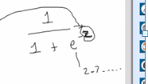
Jo result vector aayega uski value ko is formule se map kr transform krege.
Z= predicted value
E= napiers constant , value 2.7
E ki power Z nikalne k liye power function use krege.
Cost function ab mse nahi ho skta.

Ab humare paas input matrix X he.
And ek random model vector Theta
Multiply kr k predicted value aayegi.
Is predicted values pr sigmoid apply krege.
Jitney training example utni predicted values.

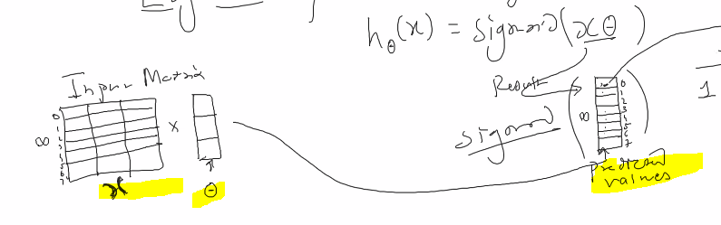
Sigmoind humne predicted value ko 0 and 1 k bich me lane k liye lagaya he

Sigmoid ka graph:
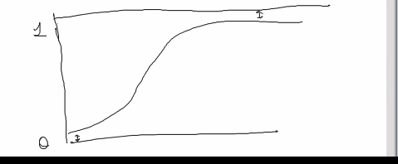
Sigmoid ka graph: 0 and 1 k bich me hi rahega , kabhi bhi 0 and 1 ko touch nahi krega.
Max cases me classification problem hi rahegii. Bs number or clasess jyaga hogi, measn abhi 2 li he in future 3,4,5….n clasees ho skti he.
Iske baad neural network , phir deep learning. Pdege.

Fun part:
Company me training ki process ya hoti he
10 saal ka exp he pr unko ml/ai me jaana he.
Family+company : time nahi bchega. Bachelor k liye sahi he ye course.
India me iska koi work dekhne k liye nahi milega.
Interview java ka pr sawal springboot k, and baate securities ki
Starter se sb configure kr k maven build .
Ese hi jb ml/ai k interview ki baar aati he , to hum jo kr rahe he usko justify krna mushkil he.

Theory full and practical then python pr jump.
And then uski library rat lo. Udr code nahi likhna he udr sb library bani he.

End of the day model.
Ek saal ho gaya ek line ka bhi code nahi likha,
Tool ka use,
Data ikkatha krna , scaling krna , bad data hatana[ bani bani script ya formula in excel]

In ml/ai what is the difference between , hypothesis function , cost function , update rule?
these 3 terms (hypothesis function, cost function, update rule) are the core building blocks of how machine learning (especially supervised learning like regression/classification) works.
Let’s break them down one by one in a clear and intuitive way:

hypothesis function:
Hypothesis means prediction function: it is a mathematical function that our model use to make prediction, it is a formula that try to guess yhat based on given input x.
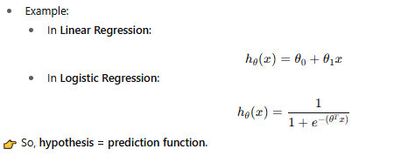
H theta x bolte he.
Theta is model so theta0 means first element of model, theta one second element of model and so on..
In x is input matrix theta0 k sath 1 tha, and baki x k sath theta1, theta2……

cost function: Goal is to minimize the cost.
it is nothing but A measure of how wrong the hypothesis (prediction) is compared to the actual
output (y). The cost function gives a score to tell the model “your predictions are this bad”.
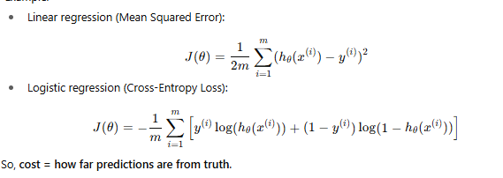
Linear regression me MSE tha , logistic me cross entropy he, cost function. Ye kisi ne phle se
decide kiya he.

update rule: it is nothing but derivative of cost function.
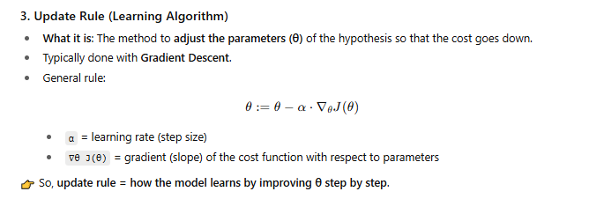
Measn model vector ko update krna ,
Theta= theta – learning_Rate * derivatie of cost function, [vectorize solution using partial derivative]

linear regression k hypothesis function me 1/2 kese aaya??
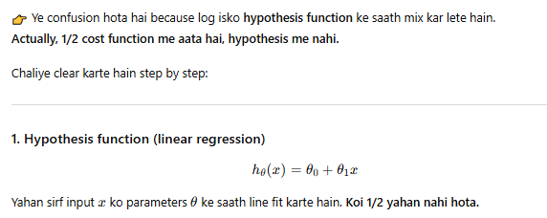

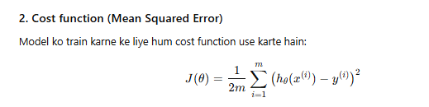

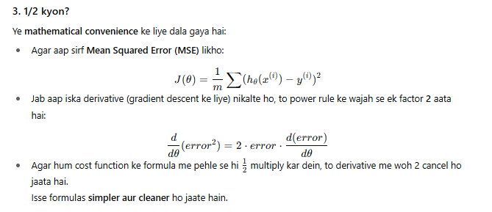
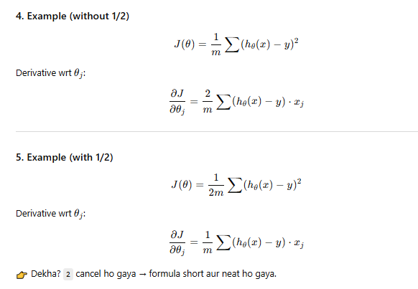
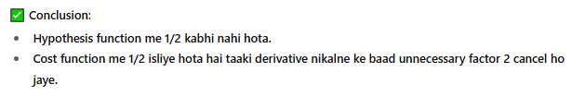

Update rule for logistic regression:
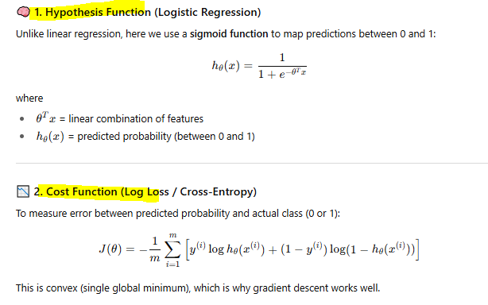
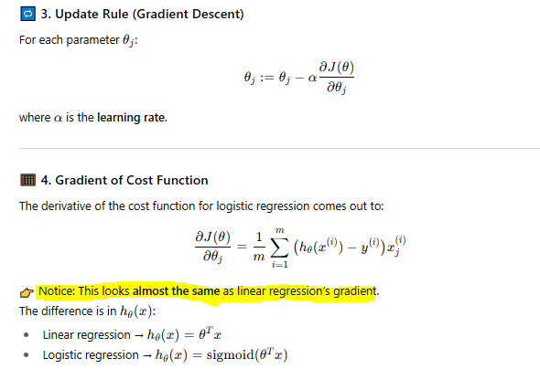
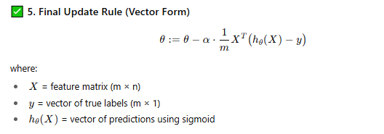
Continue lecture, part 9:
Ab logistic ki baat kre to hypothesis function
- Hypothesis function apply krna : simoid of Xtheta
- Cost compute krna losgistic me Binary cross entropy
- Model update [ya update parameteres]
To update krne ka tarika bhi bdlega, kyuki derivative jo nikla vo alag tarike ka hoga.

Below is the cost function in case of logistic regression
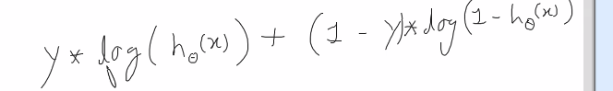

This is the cost function for 1 training example, for n training example below is the cost function
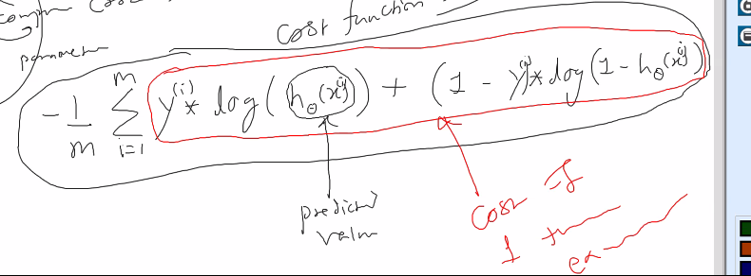
H theta is predicted value using the hypothesis function. For ith training set.
I=1 to n represent cost/ prenalty for all training example.
Ye red wale ka jo result aayega usko cost of 1 training example bolege.
is ko programetically ese break kiya
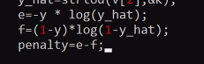

Cost function ko test krne ka program:
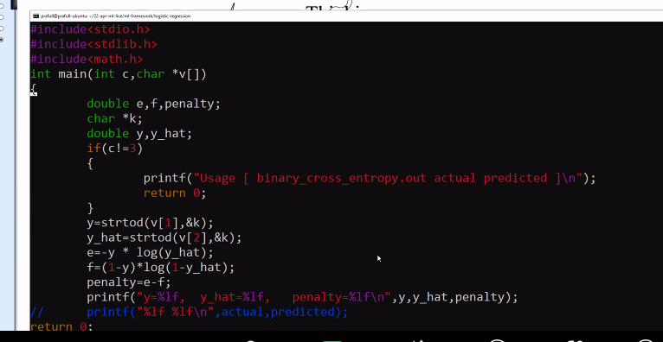

Isko compile krege to following error aayegi:
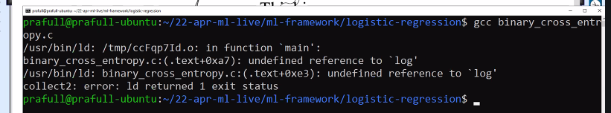
Reason: Math ko include krne k baat prototype mil jayega, but definition nahi mil rahi to uske liye library ka naam btana pdega. Us lib ka naam he m
So compile like this
Compilation example:
-I se header file kidr milege ki
-L se ye btaya ki library file kaha milegi
-l se bta rahe he ki lib file ka naam kya hoga
-lm k case me –L nahi diya kyuki usko pta he ki lib file kaha he.
libm.a
Note:
ubuntu generally servers k liye nahi rahta, server k liye sentos ya pese he to redhat.

Abhi update parameter wali baat: derivative of cost function
Apna hypothesis function tha
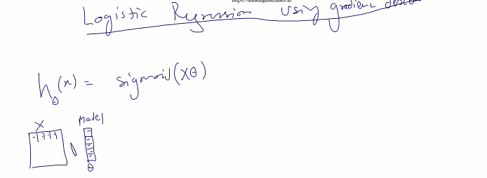

X k column and model k row are equal. Result vector aayega
Ab sigmoid function bnana pdega, Sigmoid function available nahi he.
Sigmoid vector lega and ek vector dega. Ye ho gaya predict krne wali baat
Next: cost function compute krna
Predict Vs Cost
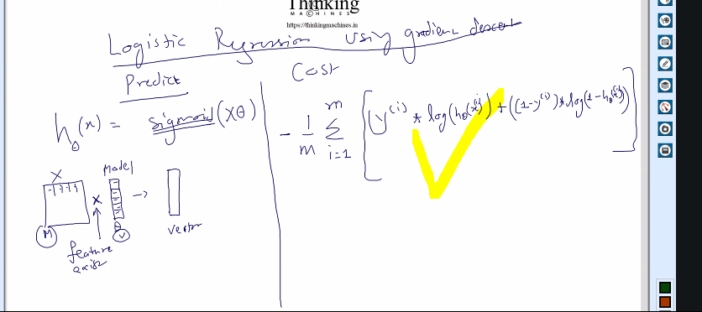
Sigmoid vector lega vector dega : ye he
Vo vector log function lega and log nikal k again vector dega. Ye lagegi
Us vector ka Y(i) k sath multiply ye lagegi. [element wise vector multilication](vector,vector) lega and vector dega.

So below are the required functionalities/infra:
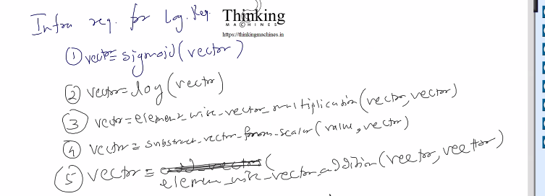
Ab ispe 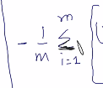 apply krna , is se scalar value aayegi . us pe 1/m se multiply
Final:
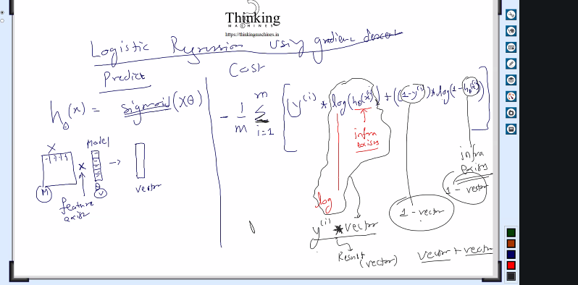
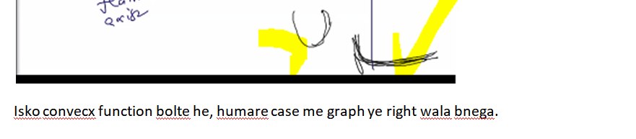
Next: Update rule for logistic, update rule kiske bharose nikal jayega?
[derivative wrt what is affecting the class] [model ki value affecting the class] so
with respect to theta partial derivative nikala jayega cost function ka.
Wrt theta1, wrt theta 2, wrt theta 3………
Means jb theta1 ko change krege to cost cost kitni km hogi and so on for other theta.
Ek theta k liye

Assignment: without using internet , find the derivative of cost function of logistic regression wrt all thetas.
Why not use internet: coz future me esi chiz bhi aa skti he jo internet pr nahi milegi, to humko internet ki aadat km honi chahiye, khud k logic build krna chahiye.
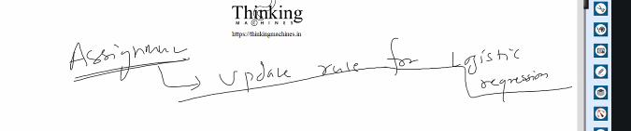
How to derive? We have formula [cost function] only we have to apply theory of derivative.

Next:
linear regression using normal equation:
Abhi , data he model he and update theta ,Phir predict But
normal equation kr k kuch he, us se iteration k bina ek shot me kaam ho jayega., iske liye phir se infra ready krna h.
Kyu normal equation implement krne me bahut saara time lgega?
Q: Time lgega isliye ye iteration wala tarika use kr rahe he? and normal equation wala use nahi kr rahe he , ya phir reason kuch or hoga?.
A: reason kuch or hoga, kuch cases me notmal equation useful he , kuch cases me iteration wala useful he.
A small answer:
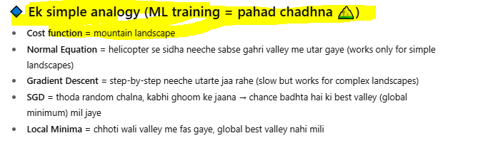
Need to investigate more on this.

Part 10 starting:
Normal equation:
- Inversion kese nikalte he, matrix ka inverse nikle ye jaruri nahi he.
- Har baar ye isliye nahi hoti coz inverse nikalna costly he.
- Inverse pr baad me kaam krege

Lets move to update rule for logistic regression:
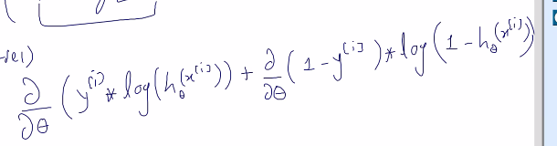
Iska derivatie nikalna he.
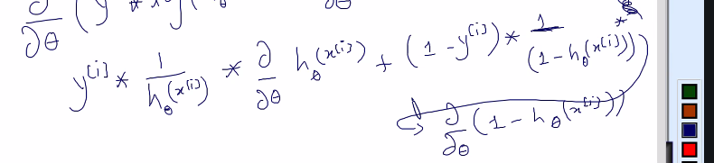
Final esa aayeg:
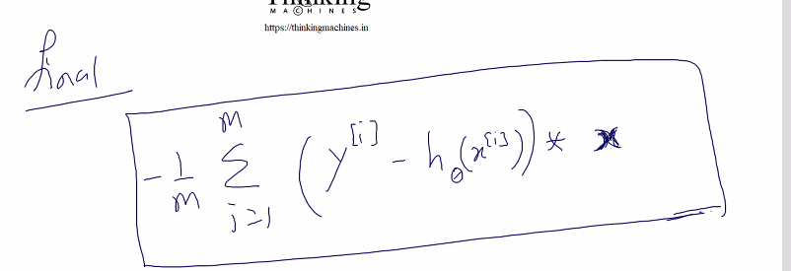
Iska use kr ke logistric regression ka model train krne wala example bna skte he
Ab or chahiye logistic regression k liya: kuch bhi nahi chahiye
Infra bna hua he kuch required chize bnani pdegi.
Cost print krwane k liye, vo cost function ko bhi programmatically convert krna pdega.

Ab naya topic :
Computaional graph and neural network.
Next refine part.

Part 9 thoda or bcha he and part 10 and 11 krna he but iske ph le logistic regression krte he.

